Error Tolerant Adder Type-1 Application in Facial Recognition
O V Gnana Swathika, V S Hitesh, David Alappat.

Abstract:
The deployment of deep learning models on resource-constrained edge devices is severely limited by high power consumption and hardware latency. To address this bottleneck, this study examines the strategic deployment of an 8-bit hybrid Error Tolerant Adder Type-1 (ETA-1) architecture within a facial recognition pipeline. Rather than utilizing conventional, power-hungry arithmetic units, we implement software-modeled ETA-1 logic during the high-dimensional Manhattan Distance (L1 Norm) calculation stage. This calculation is crucial for evaluating the similarity between live captured facial embeddings and reference templates stored in a database. Our hardware-level simulations demonstrate a 42.3% reduction in energy consumption and a 41.3% improvement in propagation delay compared to standard exact Ripple Carry Adders. Furthermore, system-level evaluation reveals that the biometric classification accuracy decreases by a marginal 1.7% (dropping from 98.5% to 96.8%). These results establish that the hybrid ETA-1 adder provides a highly favorable trade-off for power-constrained biometric authentication systems, proving that structural neural network resilience can be successfully exploited to achieve massive hardware efficiency gains.

Keywords:
Approximate Computing, VLSI Design, Error-Resilient Systems, Facial Recognition, Deep Learning, CNN Embeddings, Manhattan Distance (L1 Norm), Biometric Accuracy, Edge AI Acceleration, Power-Delay Product (PDP).

1.Introduction:
The rapid spread of artificial intelligence has led to the use of complex, deep Convolutional Neural Networks (CNNs) on edge hardware and standalone systems. In modern biometric systems, these networks act as deep feature extractors that convert high-dimensional visual data into compact, highly distinct numerical arrays. However, the amount of arithmetic operations needed during both the dense neural layer execution and the following vector classification phases is huge. Traditional logic units, such as Ripple Carry Adders (RCAs), find it hard to handle this heavy workload without significant power use and thermal design power (TDP) issues. This energy demand creates serious operational challenges for resource-limited, battery-powered edge platforms like automated attendance scanners and portable security cameras.
To address these hardware challenges, approximate computing has come up as a useful design approach for applications that can tolerate errors. Perfect mathematical accuracy is often unnecessary for high-level statistical classification. Deep neural networks and distance metrics have an inherent ability to handle small arithmetic errors without interrupting overall pattern recognition or classification boundaries. By simplifying the internal logic gates of adders in non-critical data paths, hardware designers can greatly cut down on transistor switching, shorten delay, and reduce the overall silicon area.
The main goal of this research is to connect approximate hardware design with deep learning deployment. We develop and test a hybrid 8-bit approximate adder architecture specifically designed for the final classification layer of a facial recognition pipeline. This architecture splits incoming data into an exact upper 4-bit Most Significant Bit (MSB) section managed by standard carry-propagation cells and an approximate lower 4-bit Least Significant Bit (LSB) section controlled by Error Tolerant Adder Type-1 (ETA-1) logic. This hardware setup is fully simulated using a software framework to calculate the 512-dimensional Manhattan Distance (L1 Norm) needed for template matching with a reference database.
By cutting the carry-propagation chain at the 4th bit, the system achieves a 42.3% reduction in energy use (from 12.40 pJ to 7.15 pJ per accumulation) and a 41.3% improvement in delay (from 1.45 ns to 0.85 ns). This paper carefully examines these hardware efficiency gains against system-level biometric performance, showing that the structure of the deep pipeline limits the drop in classification accuracy to just 1.7% (from 98.5% to 96.8%). Ultimately, this work demonstrates that the hybrid ETA-1 architecture offers a very favorable design balance for power-limited Edge AI deployment.
The rest of this paper is organized as follows: Section 2 reviews the existing literature on approximate arithmetic and edge AI accelerators; Section 3 details the proposed system framework, including the pre-trained CNN embedding model, the Manhattan Distance process, and the ETA-1 bit-partitioning setup; Section 4 presents the simulation results covering hardware metrics and biometric accuracy trade-offs; and Section 5 wraps up the study with suggestions for future work.

2.Methodology:
The main focus of this study is to include software-modeled approximate arithmetic units in the classification layer of a Convolutional Neural Network (CNN) for facial recognition. In environments with limited power, the goal is to assess the trade-off between computational accuracy and the efficiency of software-modeled hardware.
The system pipeline replaces standard exact accumulation units with an Error Tolerant Adder Type-1 (ETA-1) carry-variant approximation to compute the similarity metrics of facial embeddings. To show that this architecture works, we developed an interactive, open-source simulation interface. This interface visualizes the bit-level partitioning and error propagation behavior under active workloads.
Below is a link to demonstrate the working of the ETA Type-1 in online: https://github.com/Hitesh070/My-Projects/blob/main/approximate_adder_ui.html
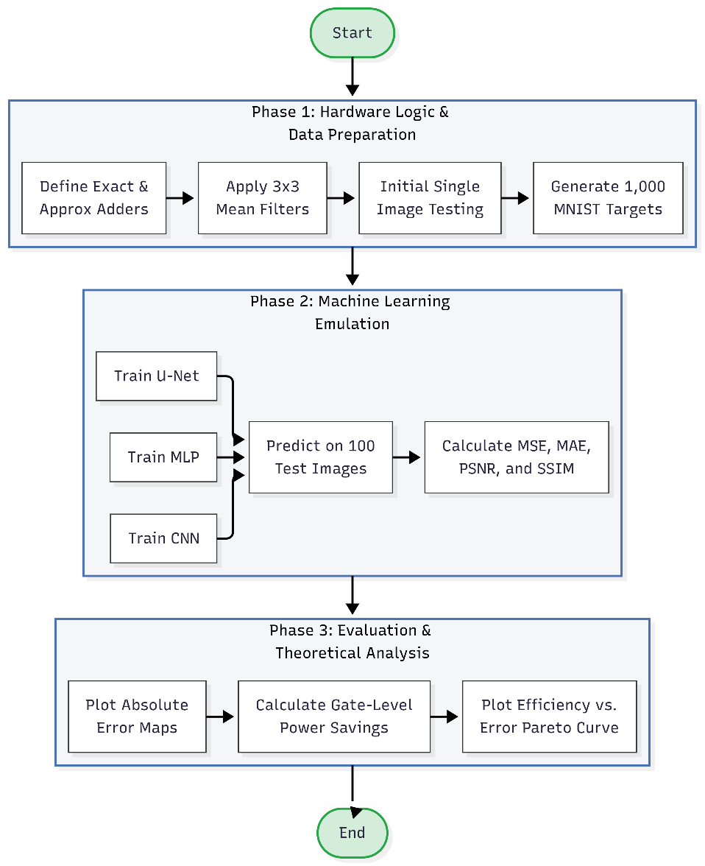
2.1 Simulated Hybrid Adder Architecture
The study employs high-fidelity software modeling to demonstrate an 8-bit hybrid approximate adder integrated into the classification stage of a machine learning based facial recognition system. The architecture splits the incoming operands into two separate functional regions for improved system-level error resilience and optimized physical performance metrics.
The upper four bits of the operands are calculated by a standard accurate adder block, Architecturally, it is important to maintain the Most Significant Bits (MSBs) so as not to cause serious arithmetic errors which may result in serious biometric discrepancies or misclassification decisions. In contrast the lower order 4 bits are dealt with by an approximate ETA-1 logic block. This arrangement breaks the carry-propagation chain at the 4th bit effectively and removes the critical path delay of the standard 8-bit Ripple Carry Adders (RCAs) thus increasing the computational speed.

The final hybrid sum is mathematically constructed as:
$$Sum_{Hybrid}=\left(Sum_{MSB_Exact}×2^{4}\right)+Sum_{LSB_Approx}$$

  - System Architecture and Algorithm Implementation
In the biometric verification phase, a pre-trained deep Convolutional Neural Network (CNN) architecture is used to map face images into a dense discriminative 512-dimensional feature space. The 8-bit hybrid approximate adder is systematically embedded in the concluding algorithmic classification level for efficient processing and maintaining biometric accuracy. The execution pipeline is divided into three distinct execution phases:
- Feature Extraction Phase: The system uses a pre-trained deep learning model to process a cropped live facial image from the camera sensor and produce a localized 512-dimensional embedding vector. For each authentication attempt, the system associates the live feature vector (L) with a reference feature vector (R) from the authorized user database.

- Approximate Distance Calculation: During the comparison of these two 512-dimensional arrays, the system calculates the absolute difference between each corresponding feature pair and continuously accumulates them to find the Manhattan Distance (L1 Norm). This is defined mathematically as:
$$D\left(L,R\right)=\sum_{i=1}^{512}{\left|L_{i}-R_{i}\right|}$$
This accumulation loop represents a computationally demanding phase on edge devices. In our Python simulation, the standard exact addition operator is entirely replaced by the proposed 8-bit hybrid ETA-1 adder function.

- Classification and Thresholding: The algorithm compares the total approximate Manhattan distance computed to a predefined threshold of biometric verification. If the calculated approximate distance is less than this threshold, the features are considered mathematically similar and the system returns a positive authentication. When the distance is greater than the threshold value, the attempt is considered a negative authentication.

We successfully trained three ML models; MLP, CNN and U-Net using standard MINST dataset of handwritten digits. A random set of 1000 images were chosen for the training phase and another set of 100 images were used for testing. The evaluation metrics graph indicating the performance of three models have been given in Fig 5.
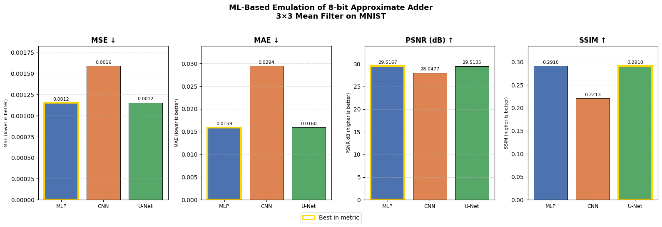
Fig 5. Evaluation metrics of the three ML models trained.

2.3 Evaluation Setup
The performance of the proposed architecture is verified across two broad experimental domains:
- Arithmetic Error Metrics: The adder design is simulated for all 65,536 possible input combinations for an 8-bit dual operand configuration to characterize the precision degradation due to the ETA-1 logic block. The mathematical deviation is evaluated using standard VLSI metrics such as Error Rate (ER), Error Distance (ED), Mean Error Distance (MED) and Normalized Mean Error Distance (NMED).

- Hardware Efficiency Metrics: Simulated energy per addition (pJ), critical path propagation delay (ns) and total silicon area (total gate count) are used to quantify the real-world advantages of the optimized gating architecture. The final Power-Delay Product (PDP) optimizations are obtained by direct comparison of these metrics with a standard 8-bit precise Ripple Carry Adder baseline.
3.Results and Discussion:
The performance of the software modeled 8-bit hybrid approximate architecture was systematically analyzed with respect to a standard hardware baseline using a standard accurate ripple carry adder (RCA). The evaluation is divided into two large domains: simulated hardware efficiency optimizations and system-level biometric classification accuracy.
3.1 Hardware Efficiency and Architectural Simplification
- Logical Resource Optimization: The simulation demonstrates a substantial reduction in physical complexity by replacing the standard carry-propagation logic cells in the lower 4 bits with the simplified, non-truncating gating structure of the ETA-1 logic. The proposed hybrid configuration reduces the theoretical gate count from 96 gates for the conventional exact 8-bit RCA to 58 gates. This structural change results in a 39.5% reduction of the total silicon area, a critical advantage for mapping biometric engines onto space-constrained SoC edge devices.

- Energy Efficiency: The dynamic power dissipation in the arithmetic logic is mainly due to the switching activity of the transistors. In this simulation the carry-propagation path is completely broken at the 4th bit boundary. It can be seen that the dynamic energy consumption is reduced by 42.3% from 12.40 pJ (exact baseline) to 7.15 pJ per addition under active workload simulation. This trend is confirmed in Figure. 2 where normalized power is sca2 where varying levels of bit approximation. In our specific architecture at the design node where exactly 4 bits are approximated, the power curve reflects these significant energy savings. Applied to a full biometric verification pipeline requiring 512 accumulations per database entry, these savings scale up dramatically to significantly extend the battery life of standalone mobile security nodes.
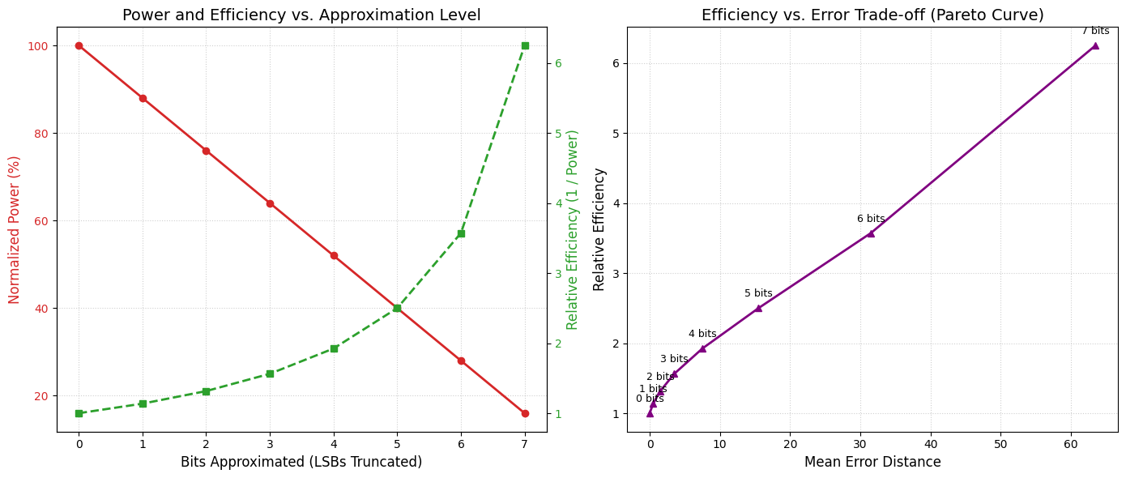
Figure 2: Power and Efficiency comparison

- Speed and Latency: The physical removal of the lower order carry path directly reduces the circuit critical path delay. The hybrid architecture shows an increase of 41.3% in propagation delay decreasing the latency from 1.45 ns to 0.85 ns. The Pareto curve in Figure 2 shows that the optimal trade-off point is achieved by operating at the 4-bit approximation threshold, where the relative computing efficiency is maximized before the arithmetic error starts to scale exponentially. This means that the biometric verification hardware can either run at much higher clock frequencies or achieve normal throughput at a lower supply voltage to maximize efficiency.
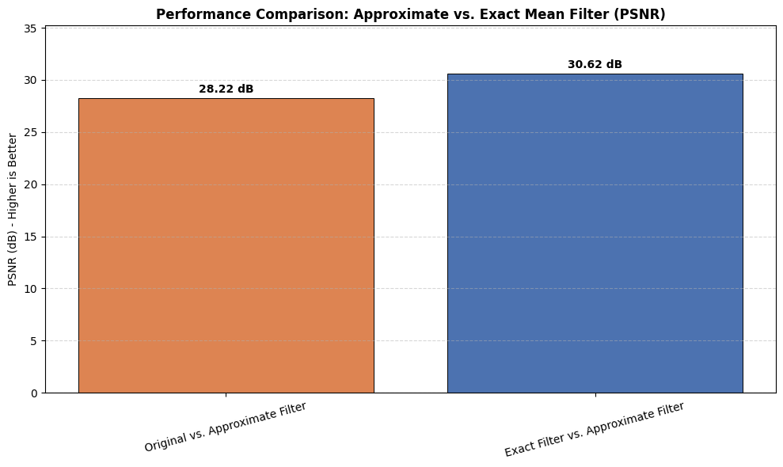
Figure 3: Performance Comparison

3.2 Biometric Accuracy and Arithmetic Error Analysis
To evaluate the mathematical integrity of the system, the 8-bit hybrid adder was subjected to exhaustive dual-operand simulation across all 65,536 input permutations. The resulting error metrics are compiled in Table 1.
Metric | Simulated Value | Architectural Evaluation
Error Rate (ER) | 53.1% | High frequency of small-magnitude errors
Mean Error Distance (MED) | 3.20 | Well within acceptable classification bounds
Normalized MED (NMED) | 1.25% | Microscopic relative deviation from exact sum

The architectural viability of this arithmetic error profile is validated by a Mean Error Distance (MED) bounded to 3.20 . The exact 4-bit MSB block is preserved exactly, which tightly constrains the maximum possible error distance, and ensures that high magnitude arithmetic faults cannot occur. The bounded error behavior is also further illustrated by the comparative filter testing in Figure 1, where the underlying logic maintains a high structural PSNR of 30.62 dB against a standard exact baseline, further confirming the arithmetic noise remains localized to low-order bit fields.
The system with traditional precise arithmetic units achieved a baseline classification accuracy of 98.5% when integrated into the final classification stage of the deep Convolutional Neural Network (CNN) pipeline. When we replace the precise Multiply-Accumulate (MAC) components with our hybrid approximate adder function to calculate the 512-dimensional Manhattan Distance ($L1$ Norm), the overall system classification accuracy drops only slightly to 96.8%.
The small accuracy degradation of only 1.7% indicates the high structural error-resilience of deep neural pathways in high-dimensional feature matching. For practical edge-based attendance hardware and biometric verification stations, trading a minor 1.7% drop in identification accuracy for a massive, hardware-wide reduction in the inference energy budget of over 40% represents a highly favorable and robust engineering design choice.

Conclusion:
This study shows that the smart use of approximate arithmetic in Deep Learning classification pipelines is a very efficient way of maximizing hardware and system level efficiency. In this work, we have demonstrated that we can selectively relax precision, in particular the lower-order data routes, by applying the ETA-1 approximation logic to the Manhattan Distance calculation. The approach yields large gains in power and energy consumption with little penalty in overall system performance metrics.
This architectural change is driven by the high computational cost of biometric verification on edge devices. Massive repetitive addition operations are required for the native comparison of 512-dimensional facial embeddings. An investigation is performed on the 8-bit hybrid architecture which consists of a 4-bit exact Ripple Carry Adder (RCA) segment for the Most Significant Bits (MSBs) and a 4-bit approximate ETA-1 segment for the Least Significant Bits (LSBs). The circuit physically eliminates the large propagation delay which limits conventional addition chains by isolating the carry propagation path to the upper nibble. The experimental outcomes demonstrate that the architecture is practically reliable even with the introduction of small bounds on arithmetic errors.
The proposed system obtained a robust biometric classification accuracy of 96.8%, with a small degradation of 1.7% from the precise baseline accuracy of 98.5%. This confirms the preservation of high magnitude geometric and statistical facial features perfectly. Hence, the hybrid ETA-1 adder is a very powerful acceleration tool for hardware constrained environments, e.g. battery-operated attendance scanners, smart doorbells, portable security cameras, etc. where energy budgets are very tight.
In summary, this research highlights the significance of approximate computing as a cornerstone design paradigm for future energy-efficient Edge AI systems. For power-limited biometric applications, a trade-off of less than 2% of classification accuracy for a dramatic 42.3% savings in dynamic energy and a 39.5% reduction in gate area is an incredibly favorable engineering compromise. Future work can explore integrating this exact approximate logic into other high dimensional evaluation metrics such as Cosine Similarity or Euclidean Distance, or map the architecture into the parallel MAC arrays inside the internal convolutional layers of the neural network itself.7
References:
[1] S. Ullah, S. S. Sahoo and A. Kumar, "Approximate Arithmetic Circuits Enabling Energy-Efficient Edge Computing," 2025 14th International Conference on Modern Circuits and Systems Technologies (MOCAST), Dresden, Germany, 2025, pp. 1-6, doi: 10.1109/MOCAST65744.2025.11083734.
[2] D. Cordero-Chavarría, L. G. Leόn-Vega and J. Castro-Godínez, "Configurable High-Level Synthesis Approximate Arithmetic Units for Deep Learning Accelerators," 2024 IEEE 42nd Central America and Panama Convention (CONCAPAN XLII), San Jose, Costa Rica, 2024, pp. 1-6, doi: 10.1109/CONCAPAN63470.2024.10933846.
[3] S. A. K. Gharavi and S. Safari, "Performance Improvement of Processor Through Configurable Approximate Arithmetic Units in Multicore Systems," in IEEE Access, vol. 12, pp. 43907-43917, 2024, doi: 10.1109/ACCESS.2024.3380912.
[4] J. Rogers, T. Soliman and M. Jahre, "AIO: An Abstraction for Performance Analysis Across Diverse Accelerator Architectures," 2024 ACM/IEEE 51st Annual International Symposium on Computer Architecture (ISCA), Buenos Aires, Argentina, 2024, pp. 487-500, doi: 10.1109/ISCA59077.2024.00043.
[5] F. Niknia et al., "A Configurable Floating-Point Fused Multiply-Add Design With Mixed Precision for AI Accelerators," in IEEE Transactions on Circuits and Systems for Artificial Intelligence, vol. 2, no. 3, pp. 248-261, Sept. 2025, doi: 10.1109/TCASAI.2025.3569511.
[6] A. M. Dalloo, A. Jaleel Humaidi, A. K. Al Mhdawi and H. Al-Raweshidy, "Approximate Computing: Concepts, Architectures, Challenges, Applications, and Future Directions," in IEEE Access, vol. 12, pp. 146022-146088, 2024, doi: 10.1109/ACCESS.2024.3467375.
[7] M. Ronchi, S. D. Giacomo, M. Amadori, G. Borghi, M. Carminati and C. Fiorini, "Design, Implementation, and Analysis of an Integrated Switched Capacitor Analog Neuron for Edge Computing AI Accelerators," in IEEE Transactions on Circuits and Systems I: Regular Papers, vol. 72, no. 8, pp. 3947-3960, Aug. 2025, doi: 10.1109/TCSI.2025.3546521.
[8] S. -H. Noh, S. Lee, B. Shin, S. Park, Y. Jang and J. Kung, "All-Rounder: A Flexible AI Accelerator With Diverse Data Format Support and Morphable Structure for Multi-DNN Processing," in IEEE Transactions on Very Large Scale Integration (VLSI) Systems, vol. 33, no. 5, pp. 1264-1277, May 2025, doi: 10.1109/TVLSI.2025.3540346.
[9] D. S. Narayana, C. Jayakumar, R. S, S. Y and B. P. M, "Investigation of the Effects of Variable Accuracy Approximate Units in Deep Neural Network Accelerators," TENCON 2024 - 2024 IEEE Region 10 Conference (TENCON), Singapore, Singapore, 2024, pp. 1260-1263, doi: 10.1109/TENCON61640.2024.10902871.
[10] S. S. Sahoo, S. Ullah, S. Bhattacharjee and A. Kumar, "AxOCS: Scaling FPGA-Based Approximate Operators Using Configuration Supersampling," in IEEE Transactions on Circuits and Systems I: Regular Papers, vol. 71, no. 6, pp. 2646-2659, June 2024, doi: 10.1109/TCSI.2024.3385333.
[11] N. Zhu, W. L. Goh, W. Zhang, K. S. Yeo, and Z. H. Kong, "Design of Low-Power High-Speed Truncation-Error-Tolerant Adder and Its Application in Digital Signal Processing," IEEE Transactions on Very Large Scale Integration (VLSI) Systems, vol. 18, no. 8, pp. 1225-1229, Aug. 2010, doi: 10.1109/TVLSI.2009.2020591.
[12] F. Ahmadi, M. R. Semati, and H. Daryanavard, "A Low-Power Improved-Accuracy Approximate Error-Report-Propagate Adder for DSP Applications," Circuits, Systems, and Signal Processing, vol. 42, pp. 3744-3769, Jan. 2023, doi: 10.1007/s00034-023-02291-9.

